|  |
| --- |
| Circle Language Spec: Interfaces |

## Interface System Command Calls

The concepts of system command call notations is not explained here. Refer to the *System Command Call Notations* article in the *System Objects* chapter for that. this is a supplement to that documentation, covering it for the Interface aspect. The Interface Merged aspect is also covered.

Cross-aspect situations can apply to the Interface aspect, but they are not covered. Cross-aspect situations between the Object and Class aspects are described in the *System Objects* chapter and adequately shed light on the topic.

### Interface – System Interface - Command Call Notation

Only one example of a call to a system command of the Interface aspect using the system interface notation will be given here. Below you will find this notation for a call to the Object-Interface Get command:

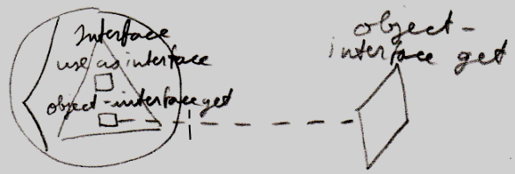

### Simplified System Command Call Notation

Below you will find the various types of calls to a system command on the Interface aspect in the *simplified system command call notation*.

|  |  |
| --- | --- |
| Use As Interface | Use Reference As Interface |
|  |  |
|  |  |
| Interface Set |  |
|  |  |
|  |  |
| Object-Interface Get | Reference-Interface Get |
|  |  |
|  |  |
|  |  |
| Interface Merged Get | Interface Merged Set |
|  |  |

### System Command Call Notation with Argument

Below you will find the various types of calls to a system command on the Interface aspect in the *system command call with argument notation*.

|  |  |  |
| --- | --- | --- |
| Use As Interface | Use Reference As Interface | Interface Set |
|  |  |  |
| Use As Interface 🡨 (Interface Set 🡪) | Use Reference As Interface 🡨  (Interface Set 🡪) | (Interface Get 🡪)  Interface Set 🡨 |
|  |  |  |
| Object-Interface Get | Reference-Interface Get |  |
|  |  |  |
| Object-Interface Get 🡨  (Interface Set 🡪) | Reference-Interface Get 🡨  (Interface Set 🡪) |  |

|  |  |  |
| --- | --- | --- |
| Interface Merged Get | Interface Merged Set |  |
|  |  |  |
| Interface Merged Get 🡨  (Value Set 🡪) | (Value Get 🡪)  Interface Merged Set 🡨 |  |

*(For the* Interface Merged *commands the argument is a* Boolean*.)*

### Explicit Get & Set Notation

Below you will find some examples of the *explicit Get and Set* notation working on the Interface aspect.

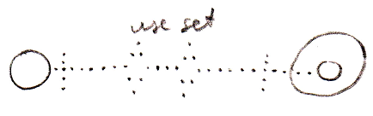

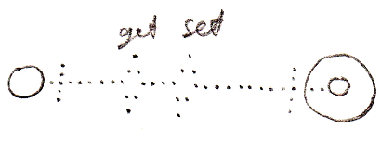

### Explicit Get & Set Arguments Notation

Below you find various notations where Get and Set arguments are explicitly drawn out, in which the Interface aspect is adressed.

